

OPERATING SYSTEMS AND SYSTEMS PROGRAMMING (25CS2104E)
2026–27, Term-I

Project Problem Statement Submission Form
Section / Team Details
Section No.: 9
Team No.:16
Project Title: Kernel Monitoring System
Team Members

Roll Number | Student Name | Signature
2520030555 | Pranav Chowdary
2520030404 | Venkatesh
2520030283 | Ritvik

Abstract

The Linux Kernel Monitoring System is a C-based system monitoring application designed to observe the current state and activity of a Linux operating system. The system collects information from the /proc filesystem to monitor running processes, process IDs, parent process IDs, process states, CPU usage, memory usage, and other system resources. It continuously updates the displayed information and detects important events such as process creation and termination. The system also records important events in a log file. This project helps in understanding how Linux provides operating system and process information to user-space applications and demonstrates important operating system concepts such as process management, resource management, nd system monitoring.
2. Problem Statement
Linux administrators need to continuously monitor system activity to understand how processes are using system resources. Manually checking individual processes and system information can be difficult and time-consuming. Therefore, this project focuses on developing a C-based Linux monitoring system that automatically collects process and system information from the /proc filesystem, monitors CPU and memory usage, detects process creation and termination, records important system events, and provides a continuously updated monitoring display

Objectives

To monitor currently running processes in Linux. To display process IDs (PID) and parent process IDs (PPID).

To identify and display process states.

To monitor CPU usage and memory consumption.

To read process and system information from the /proc filesystem.

To display important system resource information.

To detect newly created processes.

To detect terminated processes.

To record important system events in a log file.

To provide a continuously updated monitoring display.

To understand Linux process and resource management concepts.

4. Proposed Methodology
The proposed system will be implemented as a C-based user-space monitoring application on Linux.
The application will periodically read information from the /proc filesystem. Process directories such as /proc/[PID] will be scanned to identify currently running processes. Information such as PID, PPID, process state, CPU usage, and memory usage will be collected.
System-level information will be obtained from files such as /proc/stat, /proc/meminfo, /proc/uptime, and /proc/loadavg.
The application will maintain a previous process list and compare it with the current process list. If a PID appears that was not present in the previous scan, the system will record it as a process creation event. If a previously detected PID disappears, it will be recorded as a process termination event.
The collected information will be refreshed continuously at regular intervals and displayed in a terminal-based monitoring interface. Important events will also be stored in a log file for later analysis.
Basic workflow:
Start
↓
Read /proc filesystem
↓
Collect process information
↓
Collect CPU & memory information
↓
Compare current and previous processes
↓
Detect creation / termination
↓
Record important events
↓
Display updated information
↓
Wait for next interval
↓
Repeat

5. Operating Systems Concepts / Linux APIs Used
The project demonstrates the following Operating Systems concepts:
Operating Systems Concepts
- Process Management – monitoring running processes and their relationships.
- Process States – identifying running, sleeping, stopped, and other process states.
- Parent-Child Process Relationship – using PID and PPID.
- CPU Scheduling and Utilization – monitoring CPU usage.
- Memory Management – monitoring total, used, and available memory.
- Process Creation and Termination – detecting changes in the process list.
- System Resource Management – monitoring CPU, memory, load, and uptime.
- Kernel-to-User-Space Information – accessing kernel-maintained information through /proc.

6. Individual Contribution

Roll Number | Student Name | Individual Responsibility
2520030555 | Pranav
2520030404 | Venkatesh
2520030283 | Ritvik

- Tools / Platforms / Software Used
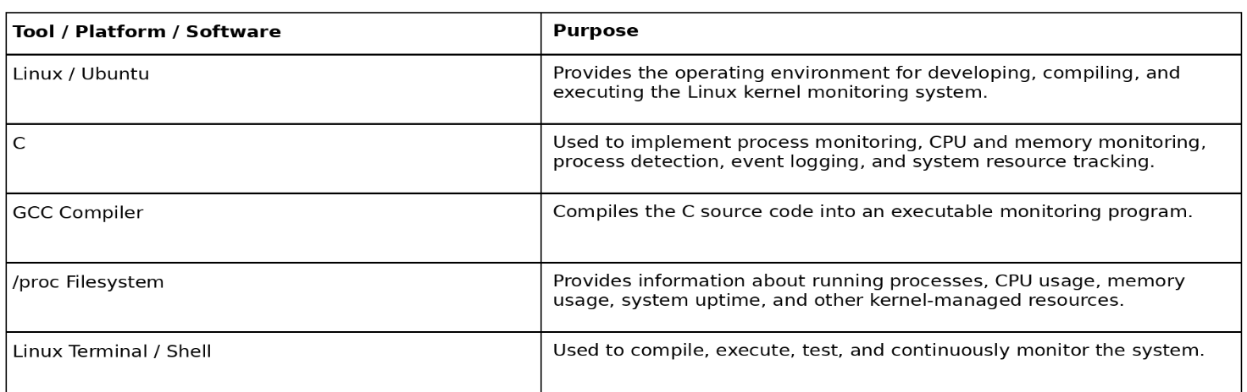

- Expected Outcome
The expected outcome of the project is a functional Linux monitoring application developed in C that provides continuously updated information about the operating system.
The system displays running processes along with their PID, PPID, process state, CPU usage, and memory usage. It also displays overall CPU and memory utilization and other system resource information. The system detects process creation and termination events and records important events in a log file.
The project provides practical knowledge of Linux process management, memory management, CPU utilization, system resources, and interaction between the Linux kernel and user-space applications.

9. GitHub Repository
GitHub Repository Link: https://github.com/ritvikreddybhavanam/KLH-CSE-2026_27-16-Bash
Repository Created:
- Yes ☐ No

Faculty Name and Signature
Faculty Name: Harika
Signature: Remarks:

Faculty Use
Project Approved:
- Yes ☐ No
Date:
Faculty Signature:

